PAD PRINTER

KEY-ONE

OPERATION MANUAL

1 General Introduction
KEY-ONE is an one-hand-operated closed ink cup pad printing machine, which has the following features:
(1). One hand can drive the rubber pad in the horizontal way or in the vertical way, while the other hand is being spared to load substrates. The whole operation is very simple.
(2). The setup of the vertical guide slot and the in-depth limiting regulating block ensures an accurate printing; Ink adding and scrapping adopt the advanced closed ink cup system, which is ink saving and environment-friendly.
(3). The worktable can be regulated upward, downward, rightward, leftward, forward and backward. And the rubber pad can also be regulated upward, downward, forward and backward as well as per a surface angle. Thus the regulation and regulation operations are convenient and fast.

2 Specifications
Specifications of the ink cup diameter: 70mm
Maximum printing size: 60mm
Pad Stroke: 120mm
: Rubber pad vertical stroke: 50mm
Worktable up and down space: 55mm.
:
Worktable left and right, forward and backward regulation space: -10mm---+10mm
Rubber pad forward and backward regulation: +-20mm
Worktable left and right regulation space: +-10mm
Size (L*W*H (mm)): 365*170*450
Weight: 22kg

3 Structure and Operation
3.1 The function of all regulation parts of the machine (refer to Picture A)
1. The lifting knob of the worktable
2. The back or front lock for the worktable
3. The back or front regulation for the worktable
4. The right or left locking for the worktable
5. The holding bar
6...The thin steel plate lock.
7. Thin steel plate for printing image.
8. Rubber pad down stroke limit.(Front)
9. Rubber pad down stroke limit (back)
10. Ink cup moving rack screw.
11. The nozzle tip, to add the lubricant to the horizontal guide axis
12. The handle
13. Rubber pad front and forward lock.
14. Rubber pad screw for adjusting the rubber pad angle
15. The rubber pad left and right lock.
16. The rubber pad
17. The ink cup (see the following note)
18. The base for the thin steel plate
19. Back plate lock for thin steel plate.
20. Back plate for thin steel plate.
21. The right-left regulating knobs of the worktable
22. The lifting bolts of the worktable

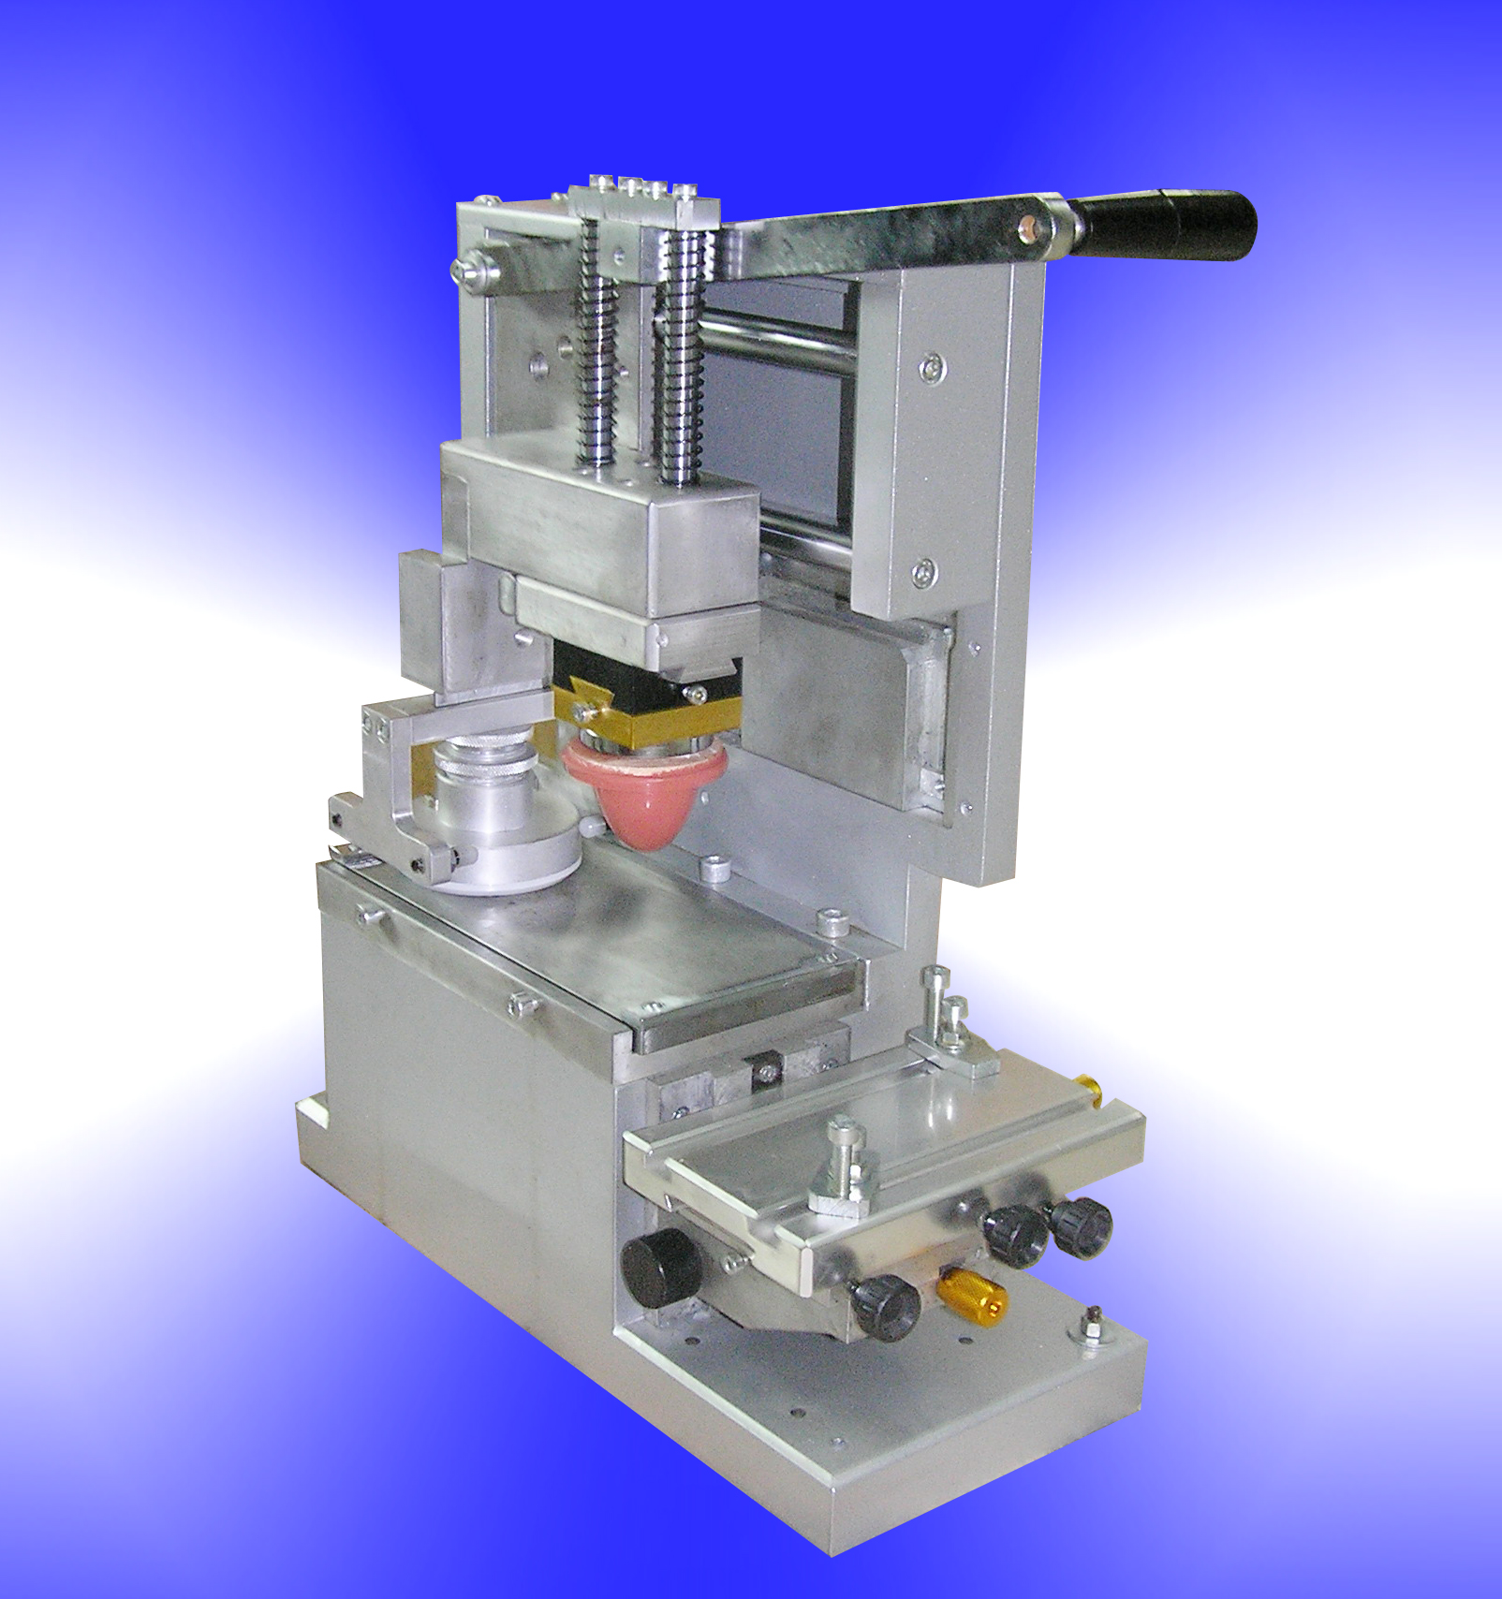
  - The ink cup, steel plate and their installation
3.2.1 The structure of the ink cup (refer to Picture B)
(1) The body of the ink cup, to contain ink and to install other parts
(2) The ceramic ring: it is a key part for scratching ink. It is highly rigid and friction-enduring but it is too fragile, thus its cutting edge needs to be carefully protected. The ceramic ring can be pulled out of the body of the ink cup if necessary.
(3) The seal ring: to fasten the ceramic ring and seal the ink. Please replace the seal ring in time if the ceramic ring is found transformed (harden or soften) when it is being pulled out
(4) The bolt lid: to add the thinner and release the gas
(5) The magnet: to attract the ceramic ring on the printing plate. It has been installed into the iron prop when it is delivered out of factories.
(6) The regulation knob: to adjust the magnet power between the ceramic ring and the printing plate by regulating the height of the magnet. When the cup is loaded onto or unloaded from the printing plate, regulate the magnet power to a low level to make the actions easier and the ceramic safer and the printing plate safer. Under the condition of ensuring a clean scratch, the small suction can even prolong the lifespan of the ceramic ring and the printing plate.
(7) The lock for the magnet: to lock it tightly to prevent the change of the magnet’s height caused by the motion.
1. Regulating knob 2. Lock nut 3. Iron pillar 4. Magnet 5.Plug screw 6. Ink pot 7. Seal ring 8. Ceramic ring 9 Lifting back 10 Club bolt 11. Lifting plate 12. Ink cup moving rack13. Ink cup 14. Printing Plate 15. Backnut 16. Regulating screw 17. Rubber caps 18 Ink cup moving rack 19. Ink cup
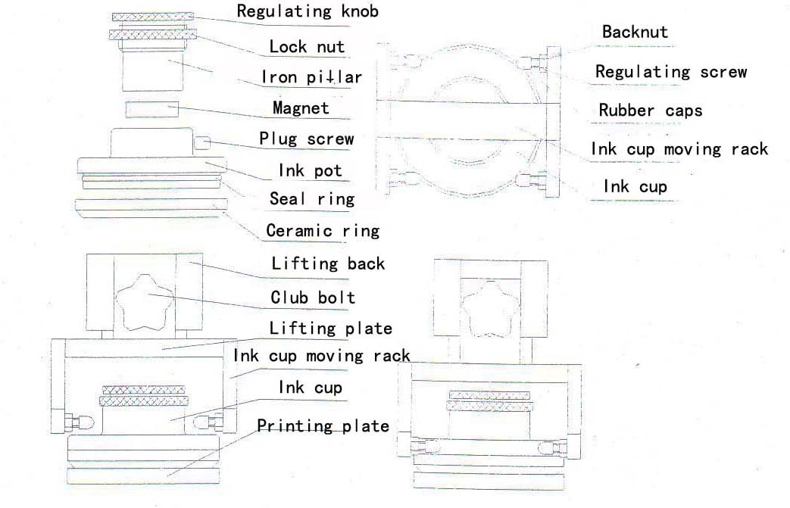
Picture B
3.2.2 The bracket of the ink cup (refer to Picture B)
The bracket leads to the motion of the ink cup through four rubber caps above it. The distance between the plastic rubber caps and the body of the ink cup can be regulated through adjusting the screw (lock it tightly with the backnut after finishing the regulation). Generally, the distance can be controlled around 0.5mm. The regulation of the relative position of four plastic rubber caps can rotate the ink cup when it moves up and down.
3.2.3 The installation of the printing plate (Refer to Picture C)
If the printing plate is a thick steel plate, directly fasten the knobs tightly to the oil holder of the ink cup with the backing plate. If it is the thin steel plate or the polymer plate, a back plate for the thin steel plate must first be used to put on the backing plate (attention: two faces which will contact should be cleaned, and at the same time, the burr on the sides of the thin steel plate should be removed away), and then lock it to the oil holder of the ink cup.
1. Thin steel plate (the polymer plate) 2. Thin steel back plate 3. Backing plate for the ink cup and the lacquer tray 4. Lock bolt for the back plate

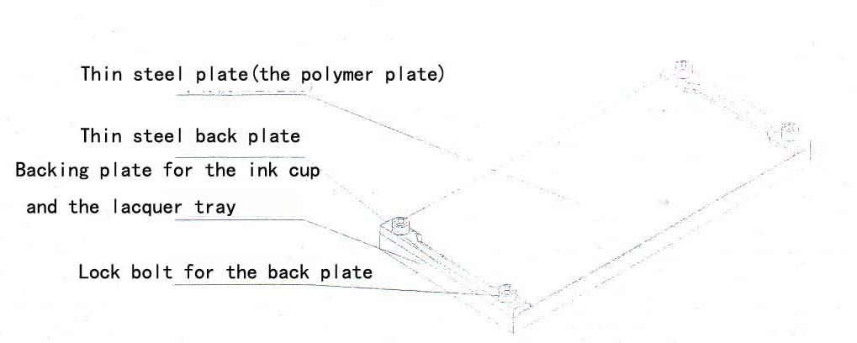Picture C
3.2.4 The installation of the ink cup (Refer to Picture B and C)
(1) Fit the ceramic ring well, load the plug screw well, rotate the magnet etc. into the body of the ink cup with two or three rounds of rotation.
(2) Turn over the ink cup and add the diluted ink. Or you can dilute the ink directly in the ink cup by mixing with a magnet-nonconductive material.
(3) Fasten the printing plate (thin steel plate or the polymer plate) to the backing plate with the thin steel back plate, turn over with the pattern surface facing down. If the printing plate is thick steel plate, pass over the above procedures and directly turn it over.
(4) Carefully put the ink cup under the printing plate and move it upward to let it absorbed with the printing plate. At the moment properly rotate the regulation knob to strengthen the suction (if the suction is strong enough, you may not regulate the knob).
(5) Loosen the club bolt, hold the bracket of the ink cup in a higher position and then lock the bracket again, then put the ink cup and the printing plate into the oil holder and lock them well. Push the ink cup right under the bracket, loosen the club bolt, put down the bracket, put the ink cup in the middle of the bracket, and lock the bracket again.
(6) The operations of unloading the ink cup are basically contrary to the above.
(7) If it is the polymer plate, what special attentions must be paid to at the unload are: firstly, the magnetic force must be regulated down; secondly, directly put the ink cup in the middle of the polymer plate or pull it directly from the center of the polymer plate. Don’t push it in from the sides of the polymer plate or let it slide out from the sides of the polymer plate. Or the polymer plate will be easily scratched.

  - The installation of the rubber pad
The position of the rubber pad can be regulated from backward to forzward or from right to left through the dovetail groove between the upslide block and the downslide block. Loosen the lock bolt, take out the fixed block of the rubber pad downward and then install the rubber pad.
1. Upslide block 2. Leftward or rightward lock nut 3. Downslide block 4. Turning nut 5. Bracket for the rubber pad 6. Forward or backward lock nut 7. Wooden bolt 8. Connecting block 9. Rubber pad
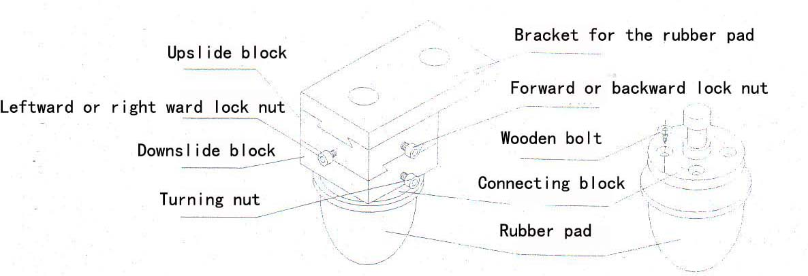Picture E
4. Operation Procedures
4.1 Install the ink cup, the steel plate and the ink well as per the methods prescribed in Article 3.2.4.
4.2 Hold the handle to move it horizontally back and forth several times, and check the removal of the ink. If there is oil leakage, please check:
(1) If the ink cup have been installed well.
(2) If there are any damage on the ink cup.
(3) If the steel plate had been installed flatly.
(4) If there is contaminated matters between the thin steel plate and the backing plate.
(5) If the ink is not suitable, too little, too dense or too thin.
(6) If the steel plate is flat or scratched.
Troubleshooting
4.3 Push the handle backwards and then press it down to ink, then adjust the position from right to down or from backward to forward (through Article 13, 14, 15)and the downward depth of the rubber pad according to its ink absorption(through Article 9).
4.4 Fit the work piece and the clamp onto the worktable.
4.5 Get the rubber pad touch ink on the steel plate and pull it forward to the proper position and then press it down for printing test. Regulate the position of the worktable from right to down or from backward to forward and the downward depth of the rubber pad according to the result of the printing. The installation position of the clamp may be regulated if necessary.
5 The rubber pad, the printing plate and ink
5.1 The rubber pad
The main material of the rubber pad is the silica gel. The quality of the rubber pad and its choice and maintenance are very important because the quality of the rubber pad (such as the elasticity, the hardness, the ink-move result, the smoothness of the surface, etc.) directly affects the printing result.
Generally speaking, a hard rubber pad should be chosen for the delicate pattern, while the soft rubber pad should be chosen when the print is proceeding on the rugged surface. The choice of the size of the rubber pad depends on the size of the pattern; of course, the best choice is the rubber pad which is just enough to cover all the size of the pattern. For the special surface of the printed work piece, the shape of the rubber pad should adapt to the shape of the to-be-printed work piece.
The surface tissue of the rubber pad is very sensitive and highly smooth, so be more careful when you clean or load and unload it. The solvents or cleansers are not allowed to clean the rubber pad because they can erode the rubber pad, and the rubber pad should not collide with or be scratched by the edge tools. The soft cloth or paper soaked with the thinner is used to clean the rubber pad when the rubber pad has dust or ink.
5.2 The printing plate
Generally, the printing plate (intaglio) adopted by the printing machine is the steel plate. The 10mm thick steel plate, the 0.3-1.0mm thin steel plate and the polymer plate are applied to the printing machine.
When the work is over, the steel plate should be washed clean and some measures (dipping it into the anti-rust oil or the antirust) should be taken to prevent it rusting. Before using it next time, the steel plate should be washed clean with the isoamylacetate.
5.3 Ink and the thinner
The choice of ink and the thinner depends on the material of the work piece (for example, PVC, PP, metals, leather, etc.) and the demands for printing patterns (such as the color, the smoothness, etc.)
In the process of the printing, the ink film is first absorbed by the rubber pad in the etching place of the steel plate and then is released from the rubber pad to the printed work piece. Therefore, there is a higher demand on the volatilization speed of the ink solvent and the proper thinner should be chosen. If the solvent volatilizes itself too fast, ink will be soon air dried on the steel plate or the rubber pad. That will lead to the result that ink can not be completely absorbed from the steel plate or ink can not be fully released from the rubber pad to the printed work piece. If the solvent volatilizes itself too slowly, ink on the printed work piece will be volatilized too slowly, easily causing ink mutually connected.
In the process of printing, the ink is adhered twice for transfer, so the viscosity of ink should be proper, while the viscosity of ink is regulated by the volume of the thinner added into ink. If too much thinner is added in, ink will be too thin, causing (1) the diaphaneity of ink down and its chain result, the dim printing color; (2) patterns with unwanted sides; (3) the ink cup to leak oil. If too little thinner is added in, ink will be too dense, causing it is difficult to scratch ink and that the printing can not go on. Although, compared with the open ink cup, the volatilization of the solvent is greatly reduced in the sealed ink cup, the viscosity of ink should still be checked during the process of printing, and the proper volume of thinner should be added in time and mixed evenly.

